Assignment 1

Create an infographic illustrating the domain driven design process highlight steps within it and a real world use case.

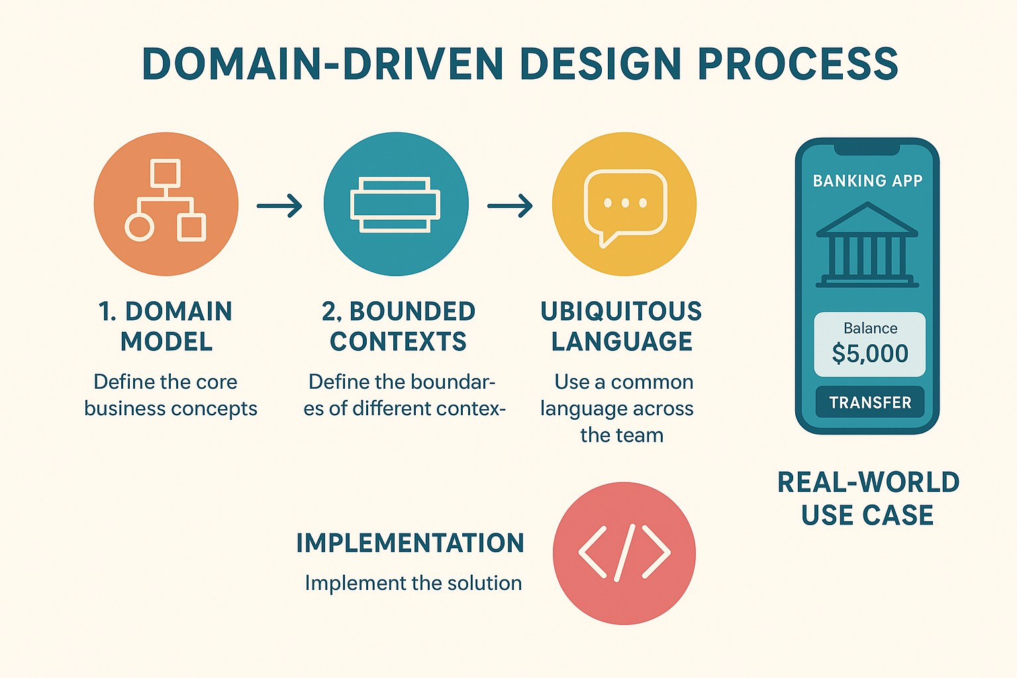

Domain-Driven Design (DDD) – Key Highlights
- Domain Model
  - Represents the core business concepts and rules.
  - Includes entities, value objects, aggregates, and domain services.
  - Example: In e-commerce, Order, Product, Customer.
- Bounded Context
  - Defines boundaries where a particular model applies.
  - Helps avoid confusion by isolating different parts of the system.
  - Example: Inventory Context, Order Context, Shipping Context.
- Ubiquitous Language
  - A common language shared by developers and business experts.
  - Ensures every term in code and discussion reflects the business meaning.
  - Example: “Cart,” “Checkout,” “Shipment” mean the same in all discussions.

Real-World Use Case: E-Commerce Platform
- Domain Model: Order, Product, Customer
- Bounded Contexts: Inventory, Orders, Shipping
- Ubiquitous Language: Cart, Checkout, Payment, Shipment

